The Doomsday algorithm

Called the "odd+11" method, the following technique allows you to find the day of the week for any date! It uses a property of the calendar: certain days of the year, which are easy to remember, always fall on the same dates. These are called the "doomsdays."
For example, the 4th of April (4/4), the 6th of June (6/6), the 8th of August (8/8), the 10th of October (10/10), and the 12th of December (12/12) are doomsdays.
In 2026, the 4th of April is a Saturday. Therefore, 6/6/2026, 8/8/2026, 10/10/2026, and 12/12/2026 will also be Saturdays. We say that "Saturday is the anchor day for the year 2026".
In 1950, the 4th of April was a Tuesday. Therefore, 6/6/1930, 8/8/1930, 10/10/1930, and 12/12/1930 were also ……………………. We say that " ………………… is the anchor day for the year 1950".
So, the method consists of two steps: (1) Find the anchor day of the year ; (2) Use the doomsdays to determine the day of the week for the chosen date.
For example, in 2026, the 5th of April is a …………………… because the 4th of April (doomsday) is a Saturday. In 1950, the 13th of October was a ……………………… because the 10th of October (doomsday) was a Tuesday.

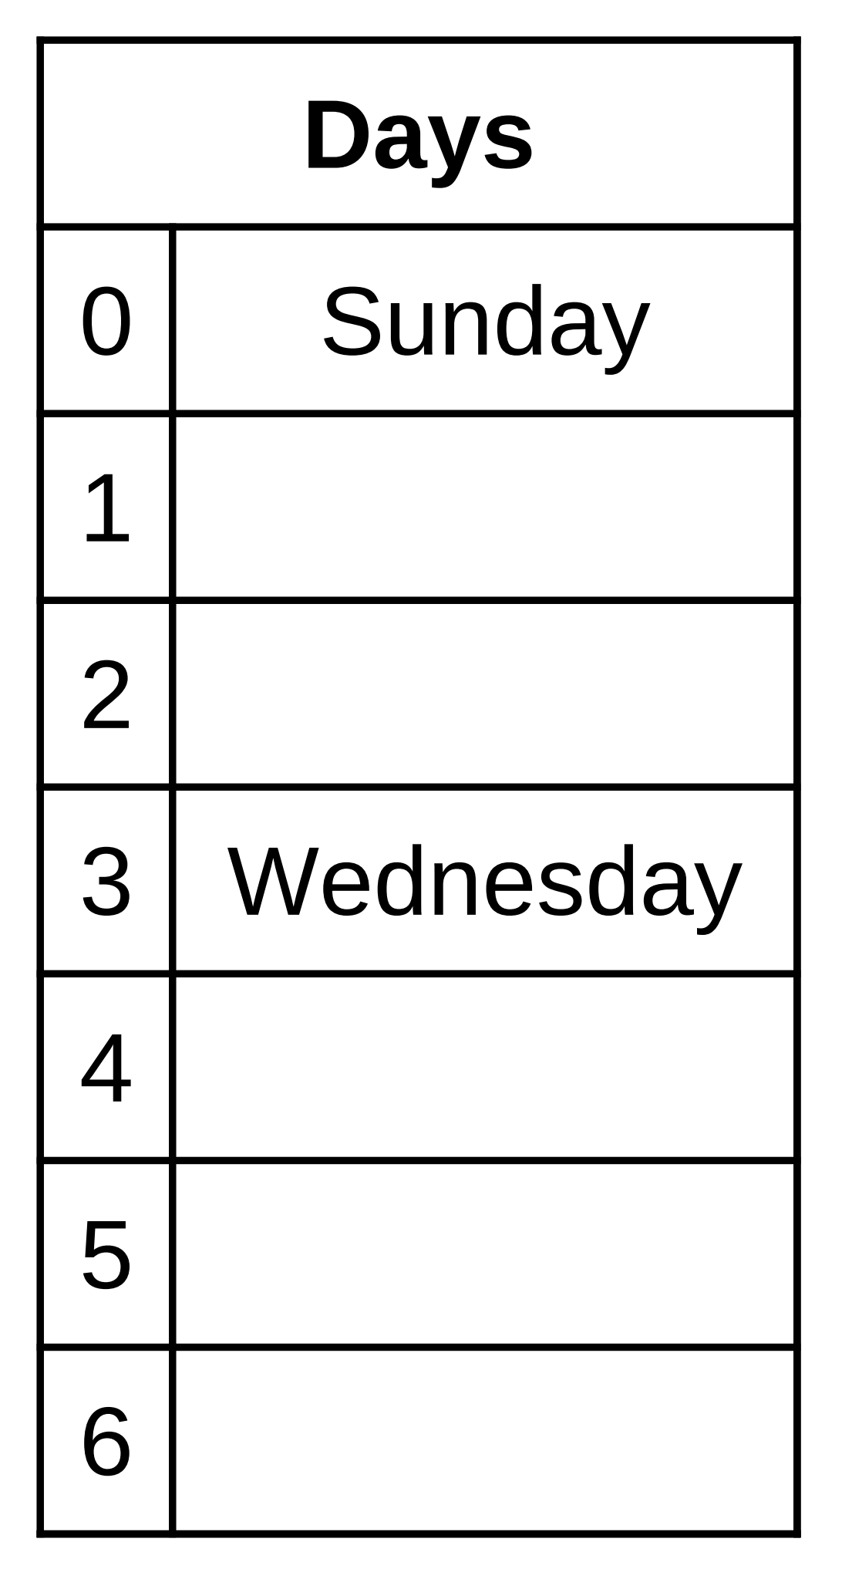
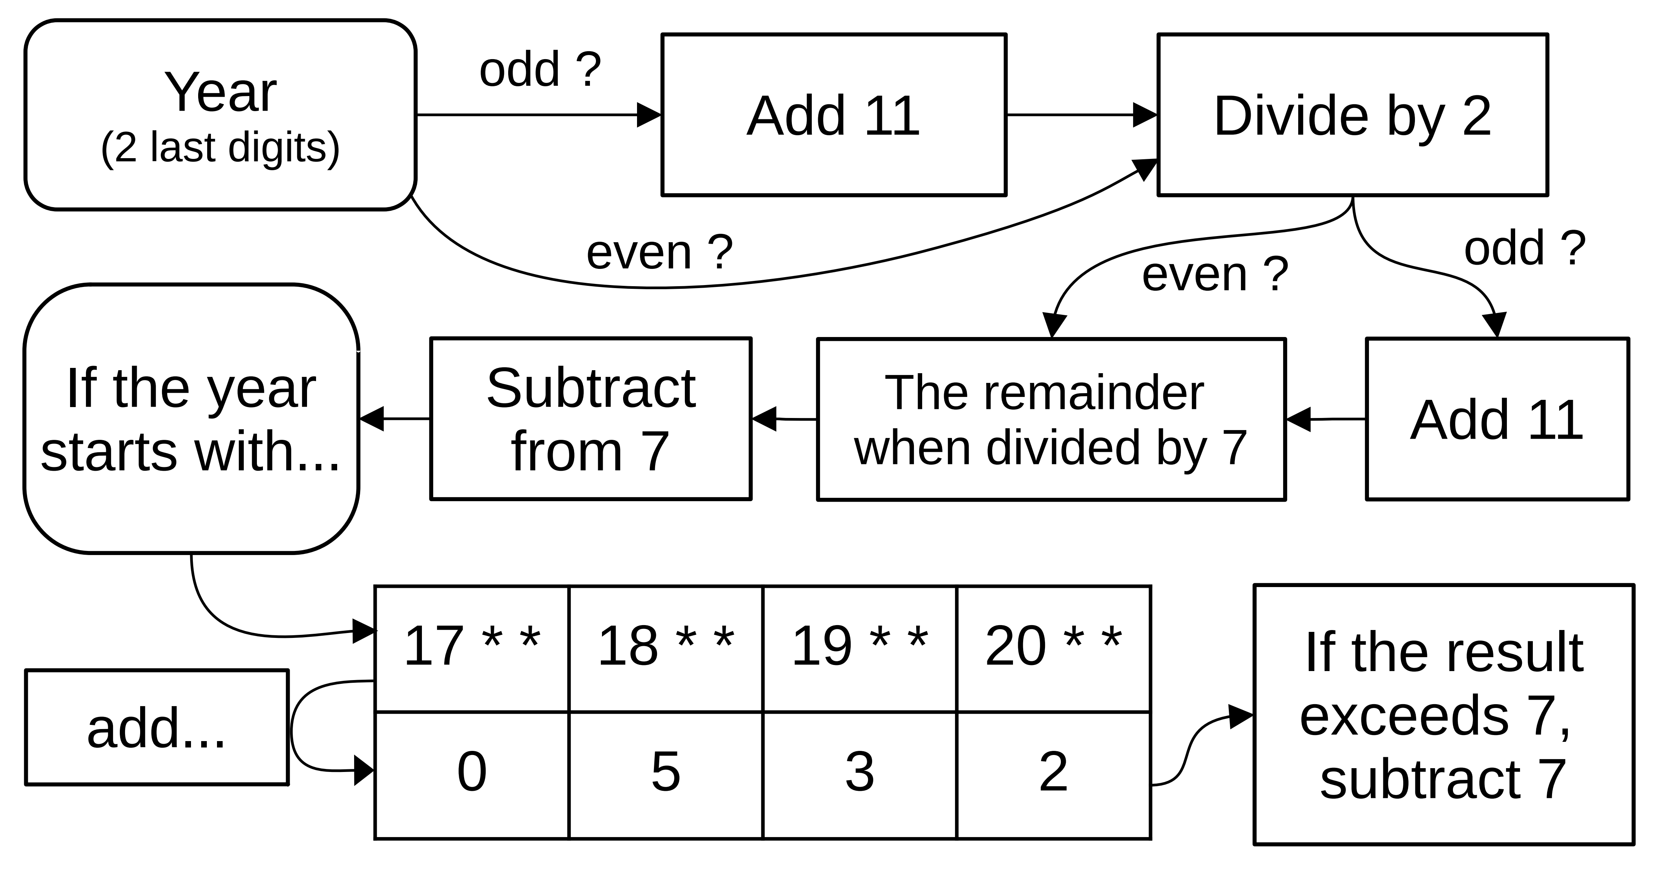
Step 1 : the anchor day of the year

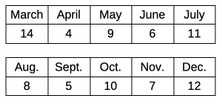
Step 2 : distance to a doomsday
A year is a leap year if it is a multiple of 4 (such as 2020, 2024, etc.), unless it is also a multiple of 100 (1800 and 1900 are not leap years), except for multiples of 400 (2000 and 2400 are leap years).
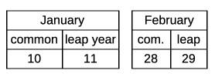

► Mnemonics for step 2
The last day of February is always a doomsday. For March, one can remember either Pi Day or "0th of March", the latter referring to the day before the 1st of March or the last day of February.
For the months April through December, the even numbered months are covered by the double dates 4/4, 6/6, 8/8, 10/10, and 12/12, all of which fall on the doomsday. The odd numbered months can be remembered with the mnemonic "I work from 9 to 5 at the 7–11", i.e. 9/5, 7/11, and also 5/9 and 11/7, are all doomsdays (this is true for both the day/month and month/day conventions).

